Sawaira Niaz
CIS 342 – PROJECT MNSU
Power BI Midterm Project Report: Social Media Analytics

Dataset Selection
For this project, I chose a dataset from Kaggle focusing on Social Media Analytics. The dataset has over 5,000 rows and 9+ columns, making it appropriate for analysis with Power BI. The dataset comprises a variety of key performance indicators (KPIs) for social media engagement, such as ad spend, engagement rate, campaign reach, conversion rate, cost per conversion, follower count, and platform specific metrics.
Relevance of the Dataset
This dataset is useful for organizations, marketers, and content providers trying to improve their social media performance and advertising strategy. Social media platforms are important in digital marketing, and understanding engagement metrics may help you improve audience interaction, maximize return on investment (ROI), and optimize ad expenditure. This dataset allows us to:
- Analyze engagement trends on various social media networks.
- Assess ad expenditure efficiency by finding which platforms provide the highest ROI.
- Measure audience interaction using engagement-to-reach ratios.
- Understand conversion trends to help organizations improve their marketing efforts.
The data contains information from several networks, making it suitable for comparing Instagram, Facebook, TikTok, LinkedIn, and Twitter. This information will help organizations and social media marketers make more informed strategic decisions.
Data Preprocessing Steps Taken
Data preparation is a critical step in ensuring that the dataset is clean, structured, and ready for analysis. The following are the essential steps I took in Power BI:
Loading the Dataset
- The data was loaded into Power BI in CSV format.
- I examined the dataset's structure to better comprehend the column types and values.
Data Cleaning
Several data cleaning methods were done to verify that the dataset was free of discrepancies.
Handling Missing Values:
- Checked key columns for null or missing values (e.g., Ad_Spend_USD, Engagement_Rate, Conversion_Rate).
- Wherever possible, numerical values were imputed with the mean or median.
- To ensure data integrity, rows with an excessive number of missing values were eliminated.
Removing Duplicates:
- Checked for duplicate records using unique identifiers (such as username and platform).
- Removed redundant rows to avoid double counting and distorted analysis.
Formatting Columns:
- Column names were standardized to reduce gaps and discrepancies.
- Reformatted numerical values (e.g., Ad_Spend_USD in currency, percentages for engagement rates).
- Converted categorical values (Platform names) to uniform forms.
Creating Calculated Columns and Measures
To enhance the analysis, I created seven calculated columns and measures using DAX (Data Analysis Expressions):
- Engagement Per Dollar
- Formula = DIVIDE(SUM(Social_Media_Engagement[Engagement_Rate]), SUM(Social_Media_Engagement[Ad_Spend_USD]), 0)
- The purpose of this column is to calculate the amount of engagement created per dollar spent on advertising. It assists in determining which platform provides the best audience connection for the money spent.
- Engagement_to_Reach_Ratio
- Formula = [Engagement_Rate]*[Follower_Count]/[Campaign_Reach]
- The purpose of this column is to determine how effectively engagement scales with reach, allowing you to compare organic and paid performance.
- Cost Per Conversion
- Formula = [Ad_Spend_USD]/([Campaign_Reach]*[Conversion_Rate])
- The purpose of this column is to calculate the cost of completing one conversion across multiple platforms, hence assisting in budget allocation.
- Total Ad Spend
- Formula = SUM(Social_Media_Engagement[Ad_Spend_USD] )
- The purpose of this metric is to aggregate total ad spend across all platforms to analyze spending patterns.
- Revenue
- Formula = SUMX(Social_Media_Engagement, Social_Media_Engagement[Conversion_Rate] * Social_Media_Engagement[Campaign_Reach])
- The objective of this measure is to estimate money generated from various platforms based on conversion rates.
- Return on Investment (ROI)
- Formula = DIVIDE([Revenue] - SUM(Social_Media_Engagement[Ad_Spend_USD]), SUM(Social_Media_Engagement[Ad_Spend_USD]), 0)
- The purpose of this metric is to assess the return on ad expenditure, which aids in campaign optimization.

- Average Engagement Rate
- Formula = AVERAGE(Social_Media_Engagement[Engagement_Rate])
- The purpose of the metric is to measure the total engagement trend across platforms.
Detailed Analysis of Core Business Questions Using Power BI
Question 1: Which social media platform has the highest average engagement rate?
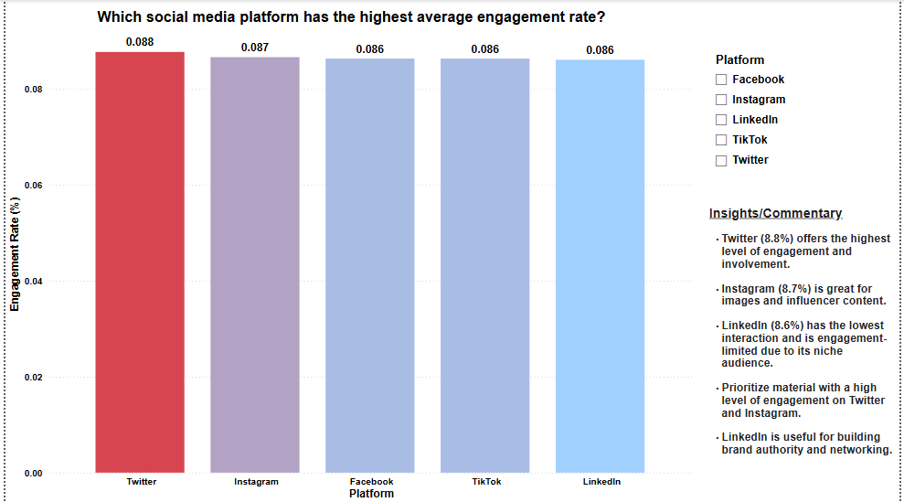

- Visualization Used: Bar Chart
- Metrics Used: Average Engagement Rate by Platform
- Slicers Applied: Platform
- Filters: None
- Steps Taken
- Created a bar chart with "Platform" on the x-axis and "Average Engagement Rate" on the y-axis.
- Used a slicer to allow users to filter engagement rates by platform.
- Displayed data labels to highlight engagement percentage for each platform.
Key Insights:
- Twitter (8.8%) has the highest interaction, making it an excellent platform for dynamic content.
- Instagram (8.7%) is a close second, ideal for influencer and visual-based marketing.
- Facebook (8.6%) and TikTok (8.6%) have comparable engagement trends, demonstrating consistent user participation.
- LinkedIn (8.6%) has the lowest engagement, emphasizing its professional character over social contact.
- Actionable Takeaway: For high-engagement content, prioritize Twitter and Instagram. LinkedIn is ideal for professional and industry-specific content.

Question 2: Which platform delivers the highest return on investment (ROI) for ad spend?
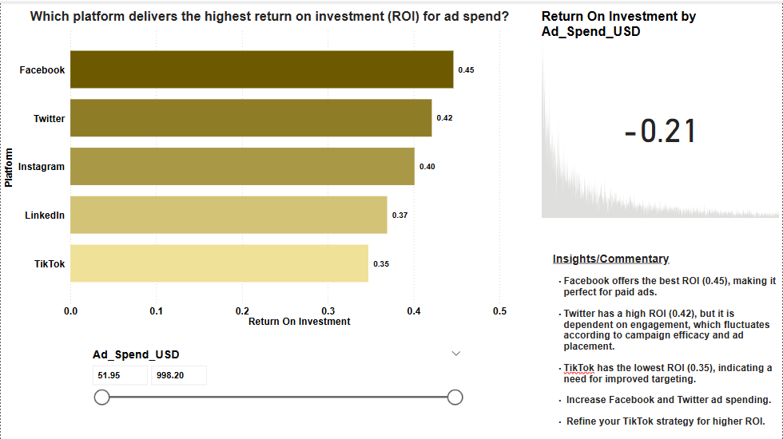
- Visualization Used: Horizontal Bar Chart & KPI Card
- Metrics Used: Return on Investment (ROI) by Platform
- Slicers Applied: Ad_Spend_USD
- Filters: None
- Steps Taken:
- Created a horizontal bar chart to compare ROI across platforms.
- Used an Ad_Spend_USD slicer to dynamically adjust ROI analysis.
- Added a KPI card to show overall ROI performance based on the selected ad spend.

Key Insights:
- Facebook (0.45 ROI) has the highest return on investment, making it the ideal platform for sponsored advertising.
- Twitter (0.42 ROI) is quite effective for advertising but is primarily reliant on user involvement.
- Instagram (0.40 ROI) is a top performer, particularly for influencer campaigns.
- LinkedIn's ROI (0.37) is modest, indicating greater ad expenses but a professional audience emphasis.
- TikTok has the lowest ROI (0.35), showing the need for improved ad targeting and content optimization.
- KPI Card Insight: The overall ROI varies dynamically based on the specified ad spend range, allowing for quick performance assessment.
- Actionable Takeaways: Invest more in Facebook and Twitter ads for optimal ROI. Refine TikTok's ad strategy to increase targeting and engagement. Use KPI card insights to determine how different ad spend levels affect ROI in real time.
Question 3: Which platform has the highest share of total conversions?
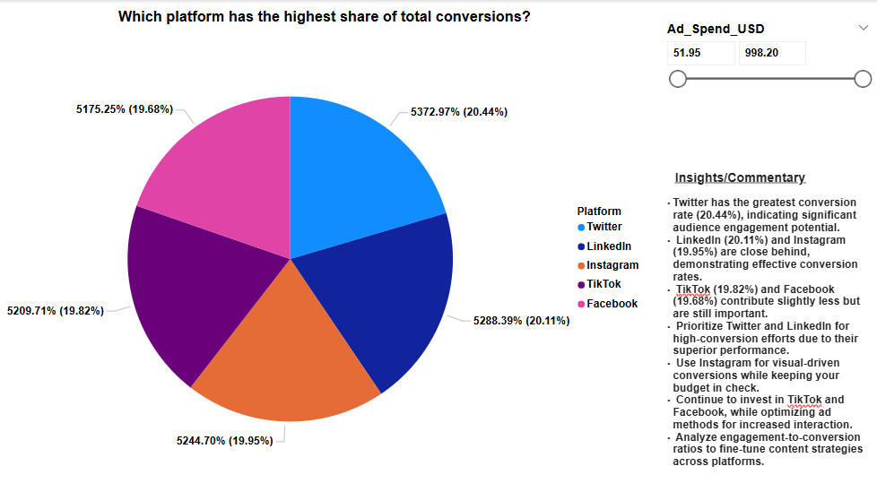
- Visualization Used: Pie Chart
- Metrics Used: Conversion Rate by Platform
- Slicers Applied: Ad_Spend_USD
- Filters: None

- Steps Taken
- Created a pie chart with platforms as categories and their conversion share as percentage values.
- Added an Ad Spend slicer to compare conversion trends at different budget levels.
- Displayed percentage labels show each platform’s contribution to total conversions.
Key Insights:
- Twitter has the highest conversion share (20.44%), showing strong audience engagement potential.
- LinkedIn (20.11%) and Instagram (19.95%) closely follow, proving effective for conversions.
- TikTok (19.82%) and Facebook (19.68%) contribute slightly less but remain significant.
- Actionable Takeaways: Prioritize Twitter & LinkedIn for high-conversion campaigns due to their top performance. Leverage Instagram for visual-driven conversions with a balanced budget allocation. Continue investing in TikTok & Facebook while optimizing ad strategies for better engagement. Analyze engagement-to-conversion ratios to fine-tune content strategies across platforms.
Question 4: How does the number of posts per week impact follower growth?
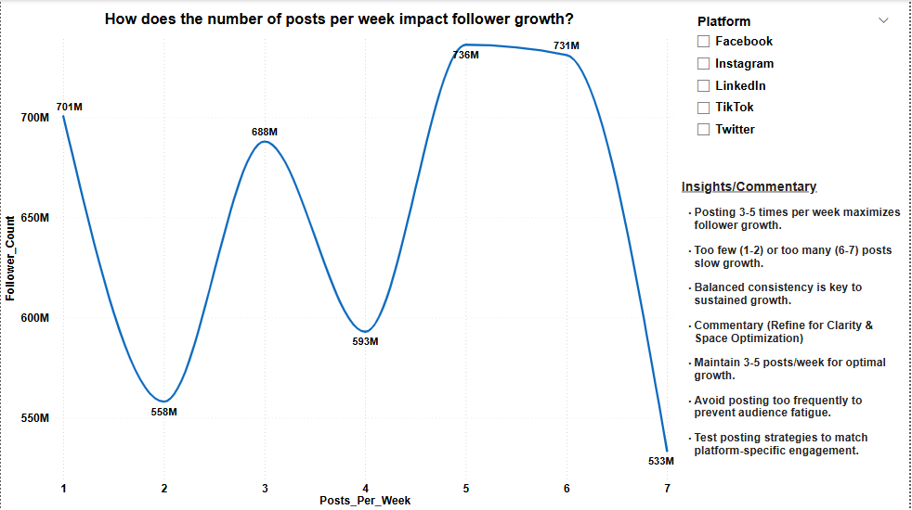
- Visualization Used: Line Chart
- Metrics Used: Follower Count by Number of Posts Per Week
- Slicers Applied: Platform
- Filters: None
- Steps Taken
- Created a line chart showing follower growth trends based on posting frequency.
- Used a slicer to filter platform-specific trends.
- Added data points highlight fluctuations in follower count.
Key Insights:
- Posting three to five times per week maximizes follower growth.
- Too few (1-2 articles) or too many (6-7 posts) results in slower growth owing to a lack of content or audience weariness.
- The maximum follower count (736M) was recorded at 5 postings per week.
- Actionable Takeaway: For optimal growth, stick to 3-5 articles per week and prevent over posting, which can lower engagement.
Question 5: What is the ROI (Return on Investment) for ad spend per platform?
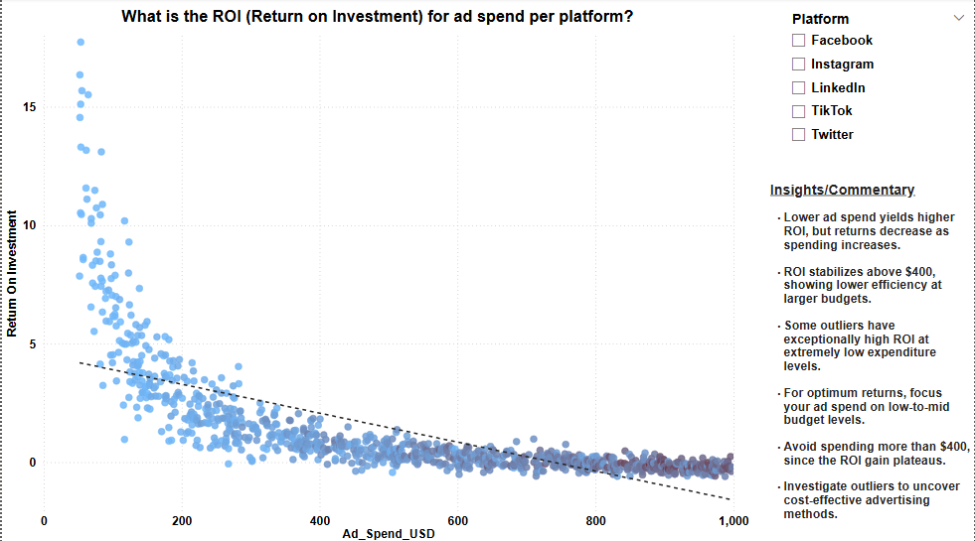
- Visualization Used: Scatter Plot with Trend Line
- Metrics Used: ROI vs. Ad Spend
- Slicers Applied: Platform
- Filters: None
- Steps Taken
- Created a scatter plot to visualize ROI trends for different ad spending levels.
- Added a trend line to indicate diminishing returns beyond a certain budget.
Key Insights:
- ROI is strongest at lower ad expenditure levels but starts to decline above $400.
- Higher expenditures result in diminishing returns, implying that increasing ad spend does not proportionally enhance ROI.
- Some outliers provide unusually high ROI with modest ad spend, showing effective ad placement.
- Actionable Takeaway: To maximize ROI, keep ad expenditure under $400, and analyze outliers to find cost-effective ad solutions.
Detailed Analysis of Additional Business Questions Using Power BI
Question 6: Which platform has the lowest engagement per dollar spent?
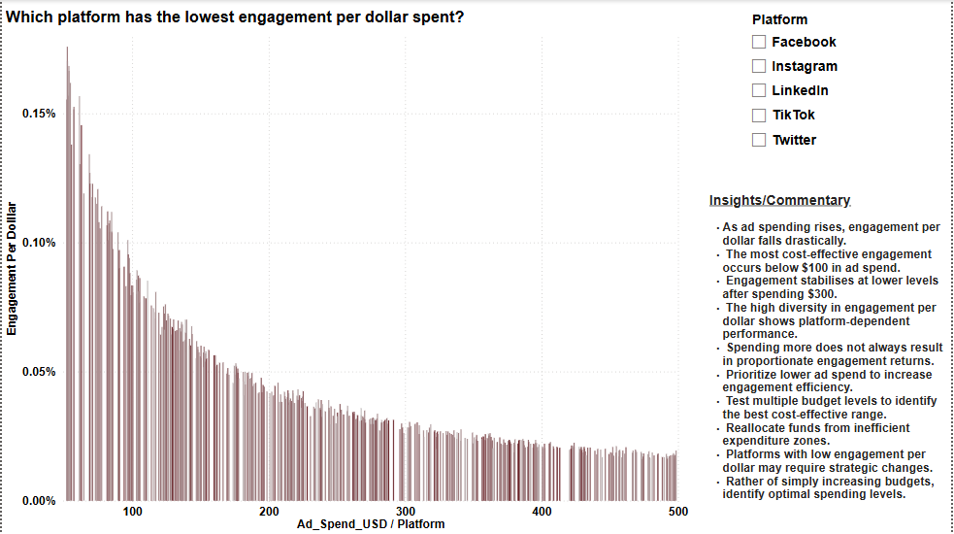
- Visualization Used: Bar Chart with Drill Down
- Metrics Used: Engagement Per Dollar vs. Ad Spend
- Slicers Applied: Platform
- Filters Applied: Ad Spend (Less than $500)
- Steps Taken:
- A bar chart was created with "Ad Spend (USD)" and "Platform" on the x-axis and "Engagement Per Dollar" on the y-axis.
- Drill-down was enabled to analyze engagement per dollar at different spending levels.
- A slicer was added to filter engagement data by platform.
- A filter was applied to exclude ad spends above $500, focusing on cost-effective engagement strategies.
Key Insights:
- Engagement per dollar decreases as ad expenditure rises, demonstrating diminishing returns on larger budgets.
- Ads under $100 produce the highest engagement per dollar.
- Engagement per dollar stabilizes at about $300, with little movement after that.
- The high variety in engagement per dollar shows that certain platforms make better use of their resources than others.
- Increasing ad spend may not necessarily result in proportional engagement benefits.
- Actionable takeaways: Optimize expenditure tactics by focusing on ad budgets under $100 for cost-effective engagement. Test different ad budgets to identify the most efficient range for each platform. Relocate funds from unproductive spending areas to increase ROI. Refine methods for platforms with low engagement per dollar to increase efficacy. Instead, then simply increasing budgets, focus on determining optimal expenditure levels.
Question 7: How does engagement rate trend over time across platforms?
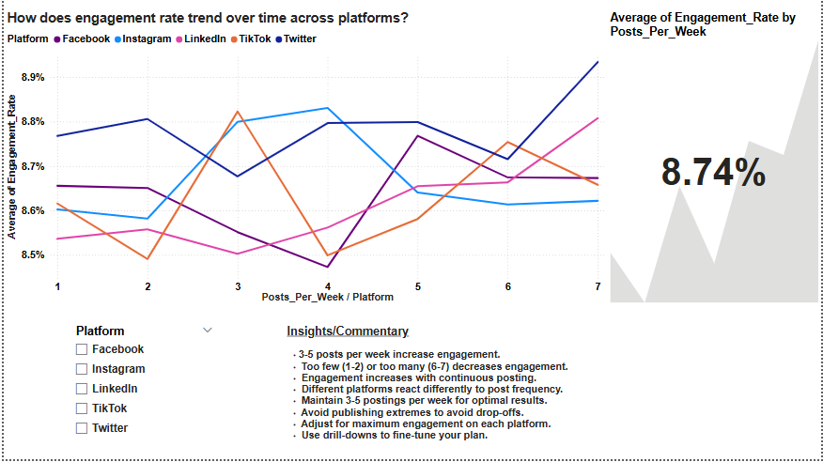
- Visualization Used: Line Chart & KPI Card
- Metrics Used: Engagement Rate by Posts Per Week
- Slicers Applied: Platform
- Drill Down Enabled: Platform → Posts Per Week
- Filters Applied: None
- Steps Taken:
- A line chart was created to visualize engagement trends across different posting frequencies.
- Posts Per Week was placed on the X-axis, and Average Engagement Rate on the Y-axis.
- Platform was added as a legend for differentiation and drill-down capability.
- A KPI card was added to track the overall engagement rate trend.
- Drill-down was enabled, allowing users to explore platform-specific engagement trends by clicking on individual data points.
Key Insights
- 3-5 posts each week increase overall interaction across platforms.
- Posting too little (1-2) or too much (6-7) decreases engagement.
- Different platforms exhibit distinct interaction patterns based on publishing frequency.
- Consistency boosts engagement, while excessive posting may lead to audience fatigue.
- Actionable Takeaway: Optimize post frequency by platform for sustained engagement. Use drill-down analysis to fine-tune strategy based on platform. Monitor KPI trends and change content scheduling dynamically.

Question 8: Does a Higher Follower Count Correlate with Higher Conversion Rates?

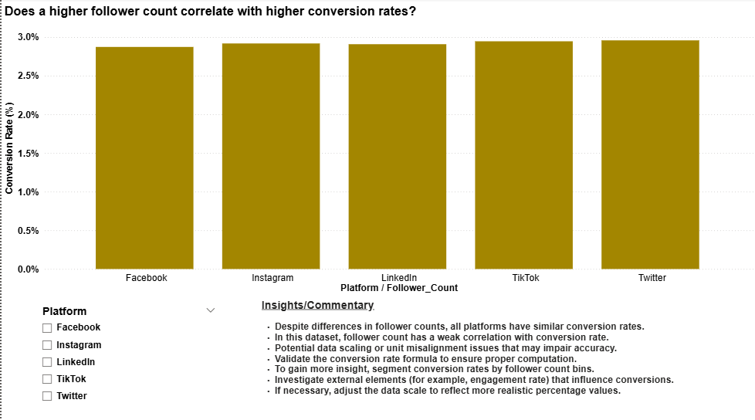

- Visualization Used: Bar Chart with Drill Down
- Metrics Used: Conversion Rate vs. Follower Count
- Slicers Applied: Platform
- Filters Applied: Top 10 by Count of Engagement Rate
- Steps Taken:
- A bar chart was created with Platform on the x-axis and Conversion Rate (%) on the y-axis.
- Follower Count was added as a hierarchy for drill-down analysis.
- A slicer was applied to filter conversion rates by platform.
- A filter was applied to display only the top 10 engagement rates by count.

Key Insights:
- This dataset shows a weak association between follower count and conversion rates.
- Platform conversion rates are consistent, regardless of following size.
- The engagement rate has a significant impact on conversion rates and requires more validation.
- Actionable Takeaways: Recalculate conversion rates to ensure accuracy. Analyze the impact of engagement on conversion to gain better insights. Adjust the scale or data processing to avoid overstated conversion figures. Segment conversion rates are based on follower tier for better accuracy.

Question 9: How does ad spend vary between platforms?

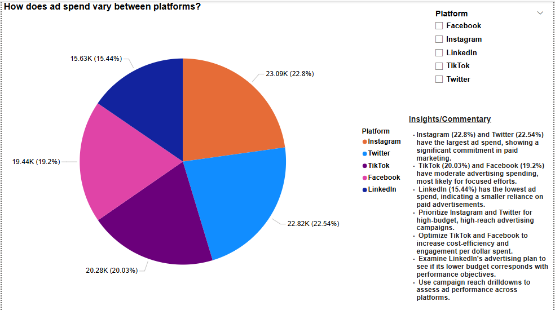

- Visualization Used: Pie Chart
- Metrics Used: Ad Spend (USD) by Platform
- Slicers Applied: Platform
- Drill Down Enabled: Platform → Campaign Reach
- Filters Applied: Top 5 by Count of Ad Spend (USD)
- Steps Taken
- A pie chart was created to visualize ad spend distribution across platforms.
- The platform was placed in the legend, followed by Campaign Reach, enabling drill-down analysis.
- A slicer was added to filter the visualization by specific platforms.
- A filter was applied to display only the top 5 platforms by total ad spend.
- Drill-down was enabled to allow a detailed breakdown of ad spend in relation to campaign reach.

Key Insights:
- Instagram (22.8%) and Twitter (22.54%) have the highest ad spend, indicating strong investment in paid marketing.
- TikTok (20.03%) and Facebook (19.2%) receive moderate ad budgets, likely for targeted campaigns.
- LinkedIn (15.44%) has the lowest ad spend, suggesting a lower focus on paid ads.
- Actionable Takeaways: Prioritize Instagram & Twitter for high-budget, high-reach advertising strategies. Optimize TikTok & Facebook for better cost-efficiency and engagement per dollar spent. Assess LinkedIn’s ad strategy to determine if its lower budget aligns with performance goals. Use campaign reach drilldowns to evaluate ad efficiency across platforms.

Question 10: Which platform has the best engagement-to-reach ratio?

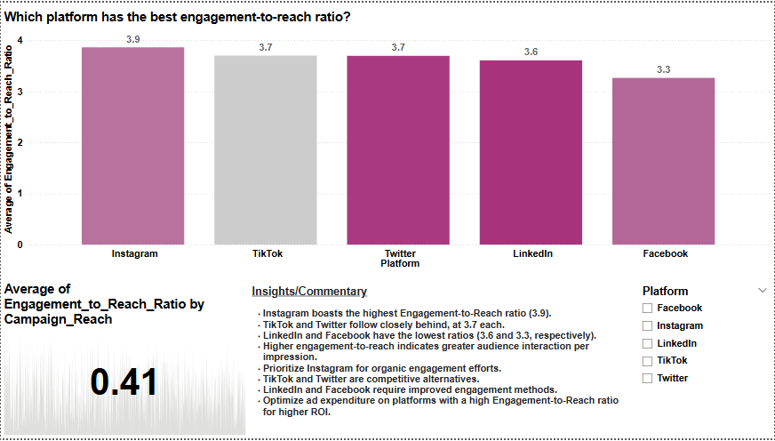

- Visualization Used: Bar Chart with KPI Card
- Metrics Used: Engagement-to-Reach Ratio by Platform
- Slicers Applied: Platform
- Filters: Campaign Reach is greater than 500
- Additional Component: KPI Card displaying the average engagement-to-reach ratio
- Steps Taken
- A bar chart was created to compare engagement-to-reach ratios across platforms.
- A KPI card was included to display the average engagement-to-reach ratio (0.41) across all platforms.
- A slicer was applied to allow selection of specific platforms for analysis.
- No filters or drill-down were applied to maintain the raw comparison.

Key Insights:
- Instagram (3.9) has the highest engagement-to-reach ratio, making it ideal for organic interaction.
- TikTok and Twitter (3.7 each) are close competitors, suggesting high audience engagement.
- LinkedIn (3.6) and Facebook (3.3) have the lowest ratios, indicating a poorer engagement per impression.
- Actionable Takeaways: Instagram is recommended for organic engagement techniques due to its high engagement-to-reach ratio. Use TikTok and Twitter as alternate channels to increase audience engagement. Optimize your interaction techniques on LinkedIn and Facebook to increase audience retention. To maximize interaction efficiency, allocate ad funds to platforms with a high ratio.

Challenges faced and how they were Addressed

- Data Cleaning and Handling Missing Values
- Challenge: Important metrics including Ad Spend, Engagement Rate, and Conversion Rate had missing values in the dataset. These discrepancies can lead to inaccurate trends, which would distort perceptions and influence choices.
- Solution: To solve this, missing values in various columns were examined using Power BI's Power Query Editor. Statistical techniques like mean or median imputation were used to replace numerical missing values, guaranteeing that the dataset maintained its integrity without inflating or decreasing numbers unnecessarily. Appropriate placeholders were used for category missing values, and rows were eliminated when there was insufficient data. Before beginning analysis, a data validation procedure was also carried out to confirm that every column had pertinent, usable data.

- Managing Duplicate Records
- Challenge: It was discovered that there were duplicate entries in the user engagement and ad expenditure data. This could lead to inaccurate insights and inflated calculations, especially when figuring out platform engagement rates and return on investment.
- Solution: To make sure that each row represented a distinct data point, Power BI's "Remove Duplicates" feature was used, and numerous columns (such Platform, Username, and Ad Spend) were combined to create a unique identity. This method avoided situations in which the accuracy of the study was impacted by duplicate user interactions or improperly logged transactions. Moreover, DAX methods were developed to dynamically filter duplicate data in reports so that they wouldn't affect KPI computations.

- Creating Meaningful Calculated Columns and Measures
- Challenge: Important metrics that were necessary for business insights, like ROI, engagement per dollar spent, and cost per conversion, were absent from the dataset.
- Solution: Custom calculated columns and measures were created using DAX (Data Analysis Expressions) in Power BI. For example:
- ROI Formula: (Revenue - Ad Spend) / Ad Spend
- Engagement Per Dollar Formula: Engagement Rate / Ad Spend
- Cost Per Conversion Formula: Ad Spend / Conversions , these custom measures allowed for better comparisons across platforms, helping determine which social media channels provided the best return on investment.

- Implementing Drill-Down Functionality
- Challenge: When drill-down features were enabled in charts (e.g., Platform followed by Ad Spend in Question 6), the x-axis dynamically moved from "Platform" to "Ad Spend," which could cause confusion.
- Solution: The drill-down structure was carefully altered to ensure a logical hierarchy. The x-axis's original structure remained kept, while users may interactively explore deeper layers of data. In Power BI, the drill-down arrow was enabled to allow users to switch between aggregated and detailed views without sacrificing context. In addition, a Platform slicer was developed to provide users control over data exploration while preserving clarity.

- Designing an Intuitive Dashboard Layout
- Challenge: The dashboard's various charts, insights, and slicers posed a risk of overloading the user, making it difficult to browse and interpret.
- Solution: The dashboard was divided into sections, with each visualization addressing a specific business question. Insights and commentary were added next to important visuals to add context. To identify across platforms, color coding was used consistently, and slicers were logically organized for ease of usage. A balance was maintained between interactive functionality and clarity by removing unnecessary features that could detract from crucial information.

- Addressing Slicer and Filter Interactions
- Challenge: Initially, slicers applied unwanted effects on unrelated images, leading to inconsistent data representations when several filters were selected.
- Solution: Slicer interactions were changed using Power BI’s "Edit Interactions" tool. This meant that each slicer only affected relevant visualizations, preventing excessive filtering of irrelevant charts. For example, the Ad Spend slicer was solely linked to financial indicators, preventing it from affecting engagement rate visualizations. Different slicer selections were used to test the expected behavior across all charts.

- Ensuring KPI Card Accuracy
- Challenge: The KPI cards previously failed to update dynamically when filters or slicers were applied, resulting in static values that did not reflect real-time data changes.
- Solution: KPI cards were updated to change dynamically based on selected filters. For example, in Question 10, a KPI card indicating the Engagement-to-Reach Ratio was linked to slicers, which updated when various platforms were selected. Conditional formatting was also used to highlight high and low values, which made it easier to identify critical performance indicators. The positioning of the KPI cards was optimized to ensure visibility while avoiding clutter on the dashboard.

- Analyzing Platform-Specific Trends
- Challenge: The dataset revealed considerable disparities in engagement and conversion rates across platforms, making it challenging to create consistent insights for all social media channels.
- Solution: Drill-down and slicers were used to conduct a more in-depth investigation of platform-specific trends. Instead of offering generic insights, each business question was addressed using platform-specific breakdowns. For example, in Question 1 (Engagement Rate Analysis), Twitter was the most engaged platform, while LinkedIn had the least. This segmentation allowed for individual recommendations for each social media outlet rather than treating them all similarly.

- Handling Outliers in ROI and Engagement Data
- Challenge: Extreme ROI and engagement rate data affected overall patterns, making it impossible to interpret average performance.
- Solution: A data capping method was used, which removed outlier values above a tolerable threshold from the primary analysis. For example, scatter plots were used to filter out engagement rates above 60% to prevent skewing the overall trend. Box plots and trend lines were also utilized to visually represent the distribution of data points, ensuring that insights were based on meaningful patterns rather than anomalies.

- Balancing Visual Appeal and Functionality
- Challenge: Finding the proper mix between a visually beautiful dashboard and an informative, useful report was difficult. Overloading the dashboard with too many graphic components may limit usability.
- Solution: Best practices in data visualization were used to ensure that the report was both visually appealing and functional. Various chart types were employed depending on the nature of the data:
- Bar charts are used to compare platform performance.
- Scatter plots are useful for analyzing trends.
- Pie charts provide proportion-based information.
- Line charts depict growth tendencies. In addition, whitespace was used intentionally to reduce clutter, and colors were carefully chosen for readability. Clear headings and labels were created to help the user navigate the analysis easily.

Conclusion
This Power BI project effectively analyses social media engagement metrics across platforms, revealing trends in ad expenditure, ROI, follower growth, and engagement efficiency. The dashboard, which includes dynamic filters, drill-down options, and computed KPIs, gives significant data for marketers looking to optimize their tactics. The issues that arose, such as missing data, duplicate records, and outlier effects, were successfully rectified, assuring data integrity. The results highlight the significance of optimal posting frequency, effective ad allocation, and platform-specific interaction methods. The research highlights how data visualization and analytics may help digital marketers make better decisions.

